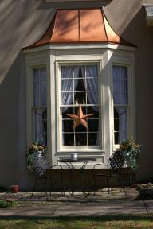

Enclosed is your cured sample of copper liquid paint. One side is coated with a clear coat to prevent the copper flakes from aging.

We apply this coating over numerous surfaces, like wood, metal, concrete, aluminum, rubber, and masonry.

In addition, copper liquid paint protects against corrosion, rust, acid rain, and fungi.

You will find it easy to apply by brush. If you want to apply by rollers or sprayer, check my BLOG (https://copperpaintcoating.com/) for suggestions to make those methods easy.

The material withstands ponding water, making it suitable for hot tubs, bird baths, gutters, and other water-collecting items.

You can scrub it clean easily.

Whenever you want, you can easily recoat it.

As you can see, the copper liquid paint is flexible and will shift with temperature changes.

Call me to discuss your project; I learned a lot over my 20 years of using the product.

See https://copperliquidpaint.com to order, or call Miriam at 267-283-6929;
Credit cards accepted.

